# Activity: Using the CALCULATE function

## **Introduction**

In this lesson, you discovered how to work with DAX and measures. One key area you focused on was how the CALCULATE function works in DAX to alter the filter context of the calculations.

In this exercise, you must apply your knowledge of DAX to modify the total revenue measure using new calculations to answer business-specific questions.

* You’ll walk through the steps to modify or create new measures incorporating the CALCULATE function in Power BI.
* The goal is to understand how the CALCULATE function behaves to compute the specific data calculations by changing the context of a DAX expression.

## **Case study**

Adventure Works needs to calculate its total revenue. The company also needs granular information about the sales performance of its employees and sales of specific products by color, subcategory, category, and region. You can help Adventure Works to generate these insights using CALCULATE DAX. This powerful DAX function defines and calculates measures according to the analytical requirements of the business.

## **Step 1: Open the Power BI project you created in the previous exercise.**

Access the project from the file path in which it was saved and open it in Power BI.

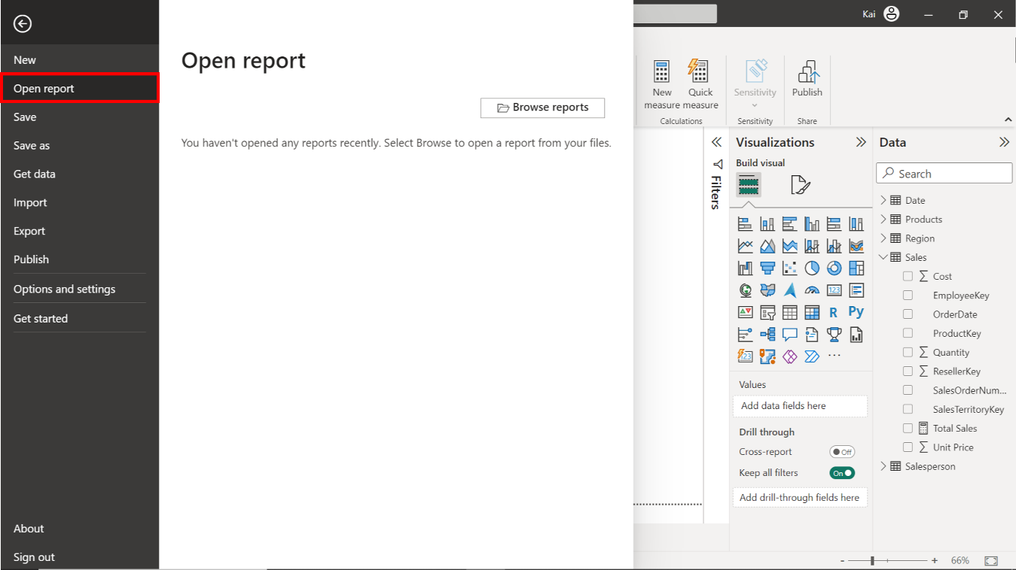

## **Step 2: Access the Total revenue measure you created using the SUMX function and modify it to calculate non-US revenue.**

1. In the case of Adventure Works, you have already created a measure called Total revenue that uses row context to compute the company's total revenue by iterating each row of the table. You must now use the CALCULATE function to introduce the new filter context to the calculation.

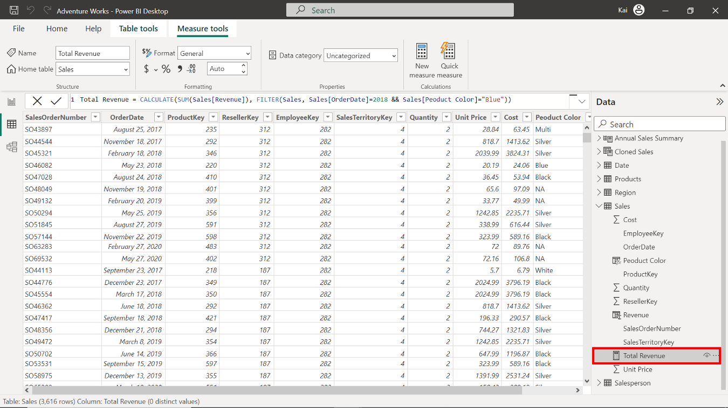

1. In the Power BI Data view or Report view, within the Calculations group, select New Measure and copy and paste the following DAX code in the formula bar to create a new measure for non-US sales.

1

2

3

4

5

Non-US Sales =

CALCULATE (

[Total Revenue],

FILTER ( Region, Region[Country] <> "United States" )

)

* The expression CALCULATE takes the total revenue measure to compute the total sales.
* It filters the value based on the country column from the Region table.
* We state that the country should not be equal to the value United States (<> DAX operator indicates "not equal to.")

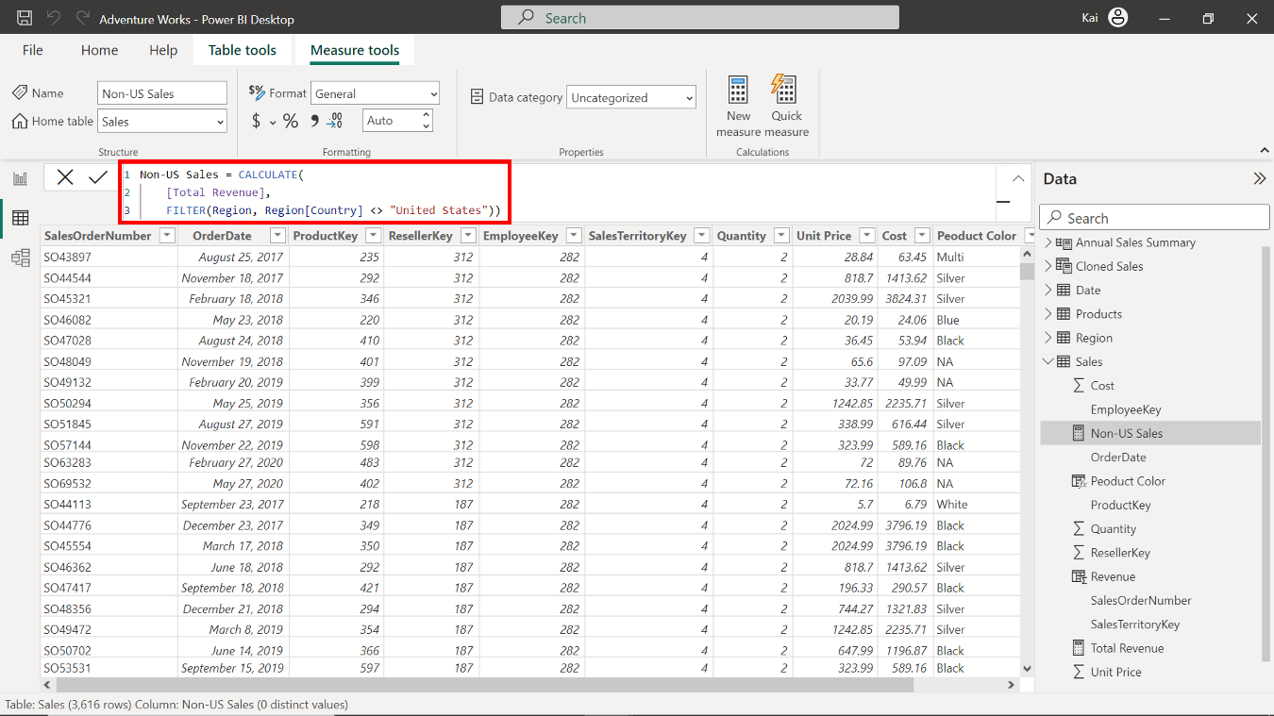

Note that the formula uses the previously created Total revenue measure. You can also modify the existing DAX code to gain the same results as follows:

1

2

3

4

5

Non-US Sales 2 =

CALCULATE (

SUMX ( Sales, Sales[Unit Price] * Sales[Quantity] ),

FILTER ( Region, Region[Country] <> "United States" )

)

* In this DAX expression, instead of using the previously computed Total revenue measure, an expression to compute the total revenue is added with the SUMX function.
* SUMX calculates the total revenue by multiplying Quantities with Unit price columns and iterates each table row.
* FILTER narrows down the sales for non-US countries from the Region table.

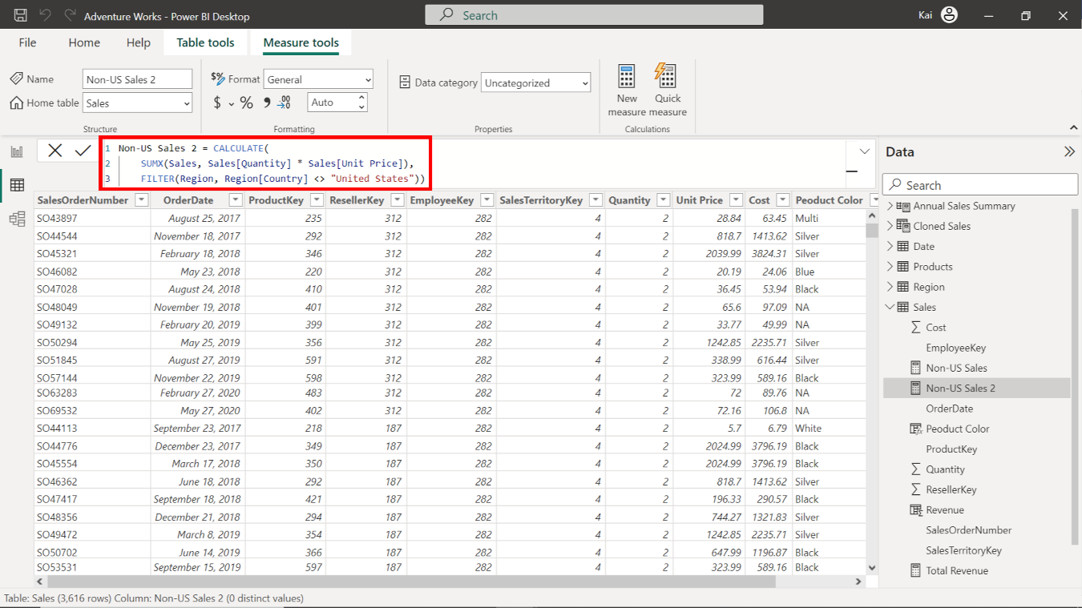

1. Once executed, the DAX code generates a new measure in the data pane.
2. Format the measure as currency with two decimal places. Select the measure you just created, navigate to the Formatting group from the Measure tools tab of Power BI. Select the currency from the format drop-down and enter 2 in the decimal place section that selects Auto by default.

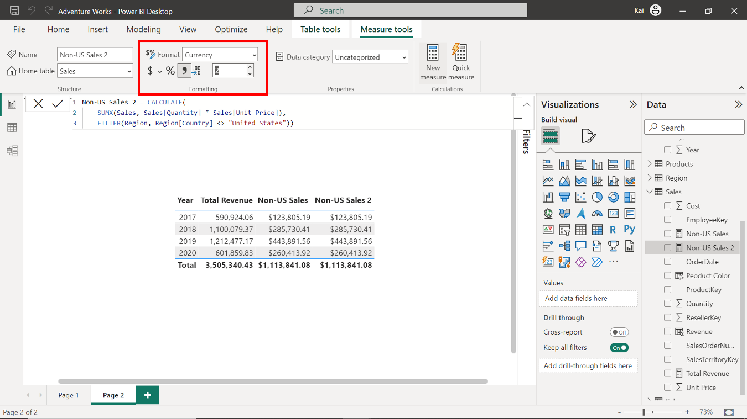

## **Step 3: Create a measure to compute the sales of black road bikes.**

1. Adventure Works wants to analyze the sales of black road bikes. You can generate insights into these sales by modifying your existing total revenue measure or creating a new one. You must use the total revenue measure within CALCULATE function to create a new measure. The measure requires that two additional filters be incorporated. The first is the Road bikes value from the subcategory column, and the second is the Product color value of Black from the Color column. The DAX code that you must input into the formula bar to complete this action is as follows:

1

2

3

4

5

6

Black Road Bikes Sales =

CALCULATE (

[Total Revenue],

Products[Subcategory] = "Road Bikes",

Products[Color] = "Black"

)

1. Format the measure as currency with two decimal places, as you did in the previous step.

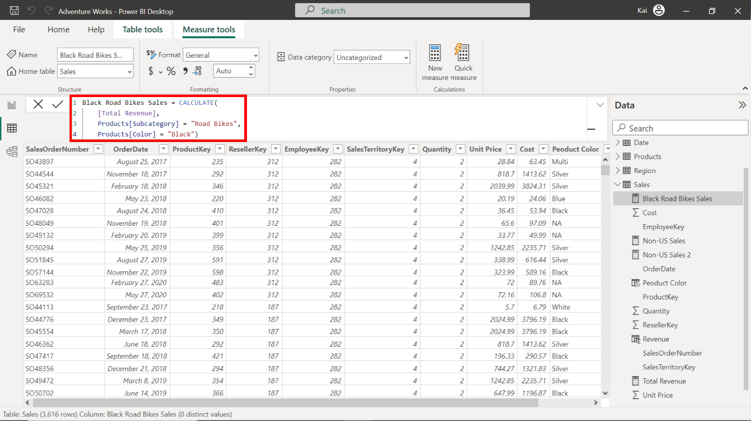

## **Step 4: Create a measure to compute the sales by Sales Managers.**

1. Adventure Works needs to generate insights into the sales performance of its sales managers. You must help them by calculating the total sales generated by each sales manager. To calculate this measure, you need to bring the filter of Employee title from the Salesperson table into the CALCULATE function. You can complete this action by adding the following DAX expression into the formula bar:

1

2

3

4

5

Sales by Sales Managers =

CALCULATE (

[Total Revenue],

FILTER ( Salesperson, CONTAINSSTRING ( Salesperson[Title], "Manager" ) )

)

* The CALCULATE function takes the total revenue measure previously created to compute the sales by sales managers.
* The FILTER function within CALCULATE filters the title column from the salesperson table.
* The CONTAINSSTRING function evaluates the title column with the defined string, in this case, its manager. It returns only the titles containing the word Manager.

1. Format the measure as Currency data type with two decimal places, as you did in the previous step.

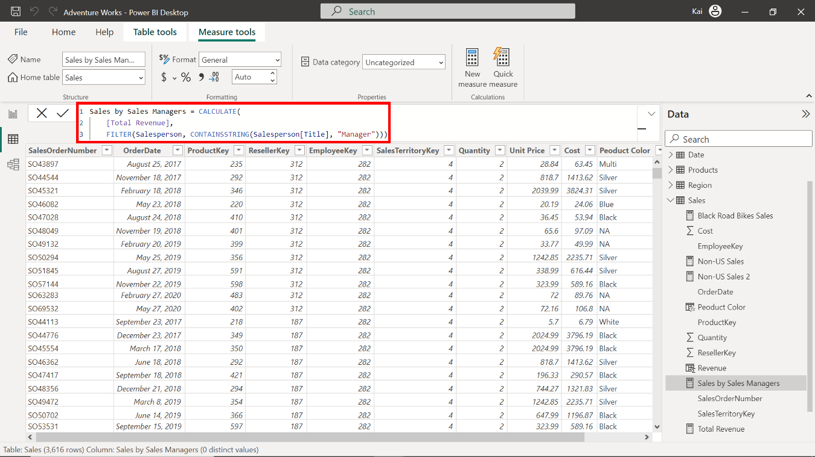

## **Step 5: Save the project.**

Save the project as a new project. Ensure to provide an appropriate name and path to the folder on your local computer.

## **Conclusion**

Congratulations! You have successfully modified and created measures using the CALCULATE function. This DAX function empowers you to create more meaningful calculations to address specific analytical needs. You can combine CALCULATE functions with filters and modifiers to achieve custom analytic goals. Mastering the evaluation context with CALCULATE will help you build efficient and scalable data solutions for your organization.